Project Report

Title: - Analysis of Consumer Food Buying Behaviour
Institute Name: - Institute of Information Technology and Management (IITM)
Submitted by: - Manpreet Kaur
Enrollment No.: - 04121188825

CONTENTS
1. Introduction
1.1. Project overviews
1.2. Objectives
2. Project Initialization and Planning Phase
2.1. Define Problem Statement
2.2. Project Proposal (Proposed Solution)
2.3. Initial Project Planning
3. Data Collection and Preprocessing Phase
3.1. Data Collection Plan and Raw Data Sources Identified
3.2. Data Quality Report
3.3. Data Exploration and Preprocessing
4. Data Visualization
4.1. Framing Business Questions
4.2. Developing Visualizations
5. Dashboard
5.1. Dashboard Design File
6. Report
6.1. Story Design File
7. Performance Testing
7.1 Utilization of Data filters
7.2 No of Calculation Field
7.3 No of Visualization
8. Conclusion/Observation
9. Future Scope
10. Appendix
10.1. Source Code (if any)
10.2. GitHub & Project Demo Link

1. Introduction
1.1. Project overviews
The food delivery industry is becoming increasingly competitive, with businesses facing growing challenges in understanding customer behaviour, optimizing delivery performance, and maximizing revenue. Despite having access to large volumes of order data, organizations often struggle to identify the key factors that influence order demand, customer spending patterns, and service efficiency. This creates a clear need for a structured, data-driven analytical approach that converts raw transactional data into actionable business insight.
This project analyses a Food Ordering Behaviour dataset of 50,000 records across 19 attributes — including Order ID, Order Value, Delivery Fee, Cuisine, Meal Type, City, Customer Rating, Company Type, Generation, and Time Taken for Delivery — using Tableau. Interactive dashboards, calculated fields, and a guided Tableau Story were built to explore how these factors influence order volume, customer preferences, and operational performance across six major Indian cities (Mumbai, Pune, Bangalore, Hyderabad, Chandigarh, and Delhi).

1.2 Objectives
- To design and build interactive Tableau dashboards that reveal city-wise, cuisine-wise, and meal-time order patterns from the food ordering dataset.
- To identify top-performing cities, high-demand cuisines, and peak ordering periods that support strategic, data-driven business decisions.
- To analyze delivery time distribution and order volume across cities in order to surface operational inefficiencies and delivery delays.
- To understand customer satisfaction patterns across cuisines and service tiers, and how they relate to repeat-order behaviour.
- To design a food ordering experience that treats every customer fairly regardless of age, while still surfacing relevant, personalized options instead of one generic list for everyone.
- To propose product features (loyalty rewards, quick reorder, weather-based suggestions) informed directly by the patterns found in the data.

2.Project Initialization and Planning Phase

2.1 Define Problem Statement
A Customer Problem Statement (CPS) exercise was used to view the problem from the customer's point of view before any dashboard was built. Three representative problem statements were defined:
Problem  Statement (PS) | I am  (Customer) | I’m trying to | But | Because | Which makes me feel
PS-1 | Someone ordering from a "Lazy" mood on a weekend | Get comfort food without any effort or decision-making | I still have to manually pick cuisine, meal type, and restaurant type every single time | there's no "just surprise me" or one-tap repeat-order option for low-effort moments | more tired than before I even opened the app
PS-2 | A Mumbai-based customer ordering breakfast before work | Place my order in under a minute so I'm not late | I end up spending 10-14 seconds just scrolling through cuisine options | the app doesn't remember or prioritize what I usually order in the morning | anxious about being late
PS-3 | A repeat customer who orders often from the same few restaurants | Get recognized or rewarded for my loyalty | my experience is identical to a first-time user — same fees, same layout, no perks | the app doesn't differentiate between new and repeat customers (is_repeat_order isn't used anywhere) | unappreciated, like my loyalty means nothing

2.2 Project Proposal (Proposed Solution)
This project proposal outlines a solution to address a specific problem. With a clear objective, defined scope, and a concise problem statement, the proposed solution details the approach, key features, and resource requirements, including hardware, software, and personnel.
Project Overview
Objective | - To design a food ordering app that shows relevant options to each customer instead of the same list for everyone.  - To treat every customer equally, regardless of their age, so that the app feels welcoming and fair for everyone — from students to elderly customers.
Scope | - Covers analysis of a food ordering dataset (order time, mood, hunger level, cuisine, restaurant type, discount, rating)  - Proposes basic app features based on this analysis, for future development  - Does not include building a real payment system or actual restaurant tie-ups, as this is only a proposed solution
Problem Statement
Description | - Most food ordering apps show the same restaurant list and menu to every customer.  - Loyal, repeat customers are not given any surprise gifts, rewards, or recognition — they get the exact same treatment as a first-time user.
Impact | - Makes the ordering process longer and more tiring, especially when the customer is in a hurry or stressed  - Can lead to cart abandonment (customer closing the app without ordering)  - Without any reward or surprise for loyalty, repeat customers have little emotional reason to stay attached to the app over competitors
Proposed Solution
Approach | - Analyze the food ordering dataset to find common patterns (e.g., which mood or weather leads to which type of order, and how often repeat customers order)  - Use this analysis to propose features that filter and suggest restaurants based on the customer's current situation, instead of a generic list
Key Features | - Weather-based food suggestions — cozy/warm food (soup, hot chocolate, pakoras) during rainy weather, and cold/refreshing food (ice cream, cold drinks, salads) during summer/hot weather.  - Quick reorder button for frequent customers.  - A loyalty card with 10 circles — one circle fills up with every order placed. Once all 10 are filled, the customer unlocks a free reward (like a free dish or discount coupon).  - Option to see discounts before opening the restaurant menu.  - Fun, friendly notifications sent whenever a new offer or discount is live — written in a cute, casual tone instead of plain boring alerts.

Resource Requirements
Resource Type | Description | Specification/Allocation
Hardware
Computing Resources | Basic computer used for data analysis | 11th Gen Intel Core i5-1135G7 @ 2.40GHz
Memory | RAM required to run analysis tools | 16 GB
Storage | Storage for dataset, code files, and reports | 5 GB
Software
Frameworks | Framework used to build the app | Google Colab / MS Excel
Libraries | Libraries used for data analysis | pandas, NumPy
Development Environment | Tools used for coding and version control | Google Colab, GitHub
Data
Data | Dataset used for this project | Food Ordering Behavior Dataset (CSV), 50,000 records, 19 columns

2.3 Initial Project Planning
The proposed app features were broken down into a 4-sprint agile plan so that the underlying data insights could be mapped to concrete user stories.
Sprint | Epic | USN | User Story | Points | Priority | Team Member | Start Date | End Date
Sprint-1 | Signup | USN-1 | As a user, I can sign up using my phone number and OTP | 1 | High | Member 1 | 01-Aug-2026 | 14-Aug-2026
Sprint-1 | Login | USN-2 | As a user, I can log in using OTP without a password | 1 | High | Member 1 | 01-Aug-2026 | 14-Aug-2026
Sprint-1 | Mood Selection | USN-3 | As a user, I can select my mood (Happy/Stressed/Lazy) so the app shows relevant food | 1 | Medium | Member 2 | 01-Aug-2026 | 14-Aug-2026
Sprint-2 | Browse | USN-4 | As a user, I can filter restaurants by cuisine type | 2 | High | Member 2 | 15-Aug-2026 | 28-Aug-2026
Sprint-2 | Cart | USN-5 | As a user, I can add or remove food items from my cart | 1 | High | Member 3 | 15-Aug-2026 | 28-Aug-2026
Sprint-2 | Discount | USN-6 | As a user, I can see if a discount applies before checkout | 2 | Medium | Member 4 | 15-Aug-2026 | 28-Aug-2026
Sprint-3 | Checkout | USN-7 | As a user, I can place my order and pick a payment method | 2 | High | Member 1 | 29-Aug-2026 | 11-Sep-2026
Sprint-3 | Delivery | USN-8 | As a user, I can see my delivery fee before confirming the order | 1 | Medium | Member 3 | 29-Aug-2026 | 11-Sep-2026
Sprint-4 | Rating | USN-9 | As a user, I can rate my order after it's delivered | 1 | Medium | Member 4 | 12-Sep-2026 | 25-Sep-2026
Sprint-4 | Reorder | USN-10 | As a user, I can reorder my last order in one tap | 1 | Low | Member 2 | 12-Sep-2026 | 25-Sep-2026

3. Data Collection and Preprocessing Phase
3.1. Data Collection Plan and Raw Data Sources Identified
Section | Description
Project Overview | This project is a data analytics study that combines a structured food ordering dataset with interactive Tableau dashboards and a Tableau Story. The primary objective is to aggregate customer demographics, order behavior, service timing, and satisfaction patterns into a unified, accessible visualization interface, allowing business analysts and food delivery platforms to readily identify ordering trends, customer satisfaction drivers, and repeat-order behavior.
Data Collection Plan | Order and customer data extracted from structured transaction records and customer feedback/ratings are gathered. This utilizes a food delivery behavior dataset containing 50,000 order-level records across 4,000 unique customers. The collected raw data is validated (no missing values or duplicates found) and transformed via calculated fields to feed into the Tableau engine.
Raw Data Sources Identified | The analytical stack is built on a single unified transactional dataset — the Food Ordering Behavior Dataset (50,000 order-level records, 4,000 unique customers, 19 fields). For clarity, its fields can be viewed across two functional groupings:  - Customer & Order Context Attributes: Demographic and situational fields captured at the time of order — age, city, order time, day type, cuisine, meal type, restaurant type, mood, hunger level, company, and weather conditions.  - Transaction & Outcome Metrics: Quantifiable results of each order — order value, delivery fee, discount applied, time taken to order, rating given, and repeat order status.  This single-source structure simplified data modeling, since no joins or key-matching across separate tables were required — all attributes exist at the same order-level grain.

Raw Data Sources
Source Name | Description | Location/URL | Format | Size | Access Permissions
Dataset 1 | Food Ordering Behavior Records (50,000 rows) | https://drive.google.com/file/d/1mAkftqbQ-DuFFyGopGyXwWjbv7QmjruD/view?usp=drive_link | CSV | 5.1 MBs | Public

3.2. Data Quality Report
The Data Quality Report will summarize data quality issues from the selected source, including severity levels and resolution plans. It will aid in systematically identifying and rectifying data discrepancies.
Data Source | Data Quality Issue | Severity | Resolution Plan
Food Ordering Behavior Dataset | Completeness Check — verified no missing values across all 19 fields and 50,000 rows | None | No action required; validated via full null-count scan
Food Ordering Behavior Dataset | Duplicate Records — checked for full-row duplication across all entries | None | No action required; all 50,000 order records confirmed unique
Food Ordering Behavior Dataset | Text Formatting — reviewed categorical fields (city, cuisine, meal type, mood, company, etc.) for spacing/casing inconsistencies | None | No action required; all categorical values consistently formatted and group correctly in Tableau
Food Ordering Behavior Dataset | Range/Outlier Check — validated numeric fields (age, order value, delivery fee, time taken, rating) against realistic bounds | None | No action required; all values within expected ranges

3.3. Data Exploration and Preprocessing
Section | Description
Data Overview | A comprehensive food ordering behavior dataset containing 50,000 order-level records with key demographics (age, city), order context (cuisine, meal type, restaurant type, time of day), behavioral metrics (mood, hunger level, company, weather), and transaction outcomes (order value, delivery fee, rating given) used to evaluate customer ordering patterns and service quality.
Data Cleaning | Missing Values: Scanned all 50,000 rows across 19 fields; confirmed zero incomplete records, so no rows required removal. Duplicates: Checked for redundant order entries; confirmed zero duplicate records, preserving full data integrity. Error Correction: Verified all categorical values for double spacing, irregular casing, and trailing whitespace; confirmed all category values were already clean and consistently formatted.
Data Transformation | Calculated Fields: Formed grouped classifications — standardizing Order Value into Premium/High/Medium/Low tiers and Age into generational risk-free segments (Gen Z, Young Millennials, Older Millennials). Aggregations & Pivots: Implemented AVG/SUM calculations with a parameter-driven metric selector and RANK table calculation to cross-examine core attribute performance. Filtering: Applied a Top N parameter to isolate top-performing records; confirmed no extreme outliers fell outside realistic order-value or rating variance limits.
Data Type Conversion | Validated that order_id and user_id are classified as non-numeric identifier strings, biometric-style numeric attributes (age, order_value, delivery_fee, time_taken_to_order, rating_given) are assigned integer values, and true/false flags (discount_applied, is_repeat_order, rainy_weather) are strictly mapped to explicit Yes/No text values to prevent syntax failures inside Tableau.
Column Splitting and Merging | Reviewed all fields for multi-variable strings requiring separation; confirmed each raw column (e.g., city, cuisine, meal_type) already represented a single, clean categorical attribute, requiring no splitting or merging to enable responsive dashboard filtering.
Data Modeling | Established a single flat order-level table model, using user_id as the key linking repeat customers across multiple orders. Calculated global operational ratios like average rating, average delivery time, and repeat-order percentage using multi-factor calculated fields.
Save Processed Data | Exported the fully validated dataset from its raw CSV state into a structured file format, verifying column headers and field widths to ensure complete visibility before transferring to Tableau for visualization.

4. Data Visualization
4.1. Framing Business Questions
These are business questions were framed to guide the creation of meaningful, actionable Tableau visualizations, spanning revenue, cuisine, satisfaction, geography, and loyalty:
Q1. Which cities generate the highest order value?
Q2. How does order value vary across different cuisines?
Q3. How is order value segmented across meal types and spend categories?
Q4. How do customer satisfaction ratings vary by cuisine and rating band?
Q5. What do the key operational metrics look like at a glance?
Q6. How is order value geographically distributed across cities?
Q7. How do cities rank comparatively on total order value?
Q8. How are total orders distributed across cities?
Q9. Does dining companionship type affect customer satisfaction ratings?
Q10. Does repeat order rate vary by generation?

4.2. Developing Visualizations
The process involves defining specific business questions to guide the creation of meaningful and actionable visualizations in Tableau. Well-framed questions help in identifying key metrics, selecting relevant data, and building visualization that provide insights.
Q1. Which cities generate the highest order value?
- Visualization: Bar chart (Top N filter) showing order value by city, ranked and limited to top 3.
- Insight Provided: Mumbai generates the highest order value at ₹4,640,319, followed closely by Pune (₹4,616,213) and Bangalore (₹4,539,656). The narrow gap between the top 3 cities (~₹100K) indicates strong, evenly distributed demand across major metros rather than a single dominant market — useful for prioritizing delivery fleet allocation and city-specific marketing budgets without over-indexing on one location.
- Screenshot of visualization:
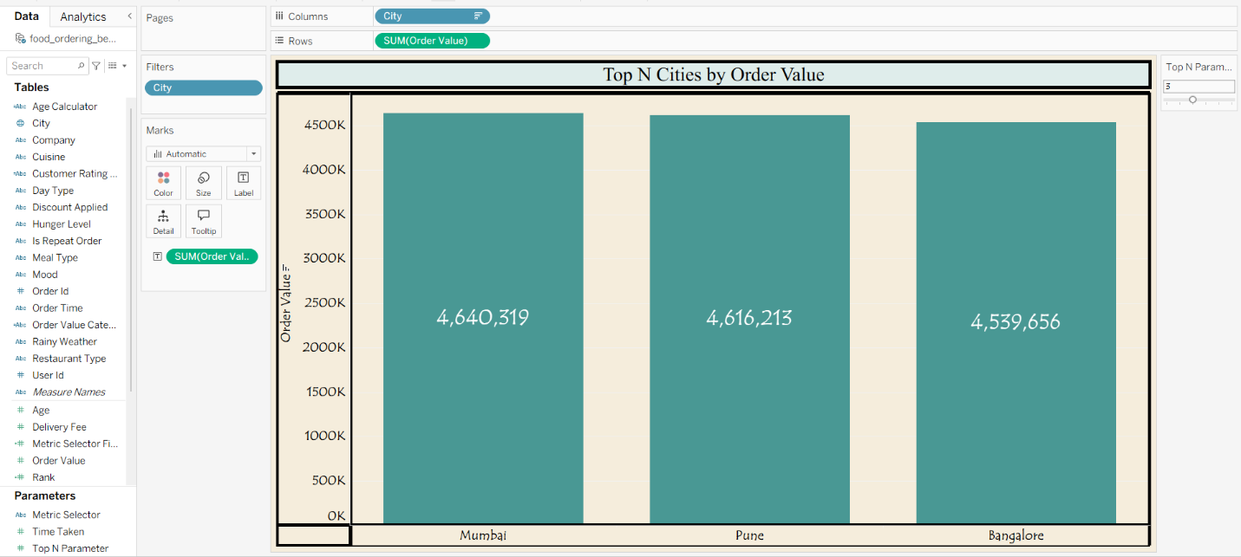

Q2. How does order value vary across different cuisines?
- Visualization: Lollipop chart (bar + circle marks) showing sum of order value by cuisine type.
- Insight Provided: Desserts led with ₹4,627,202 in order value, followed by Fast Food (₹4,592,774) and South Indian (₹4,582,780), while North Indian trails at ₹4,466,788. This indicates indulgence/treat categories (desserts, fast food) may have higher price points or larger basket sizes than staple meal categories — useful for promoting higher-margin cuisines through bundling or upselling.
- Screenshot of visualization:
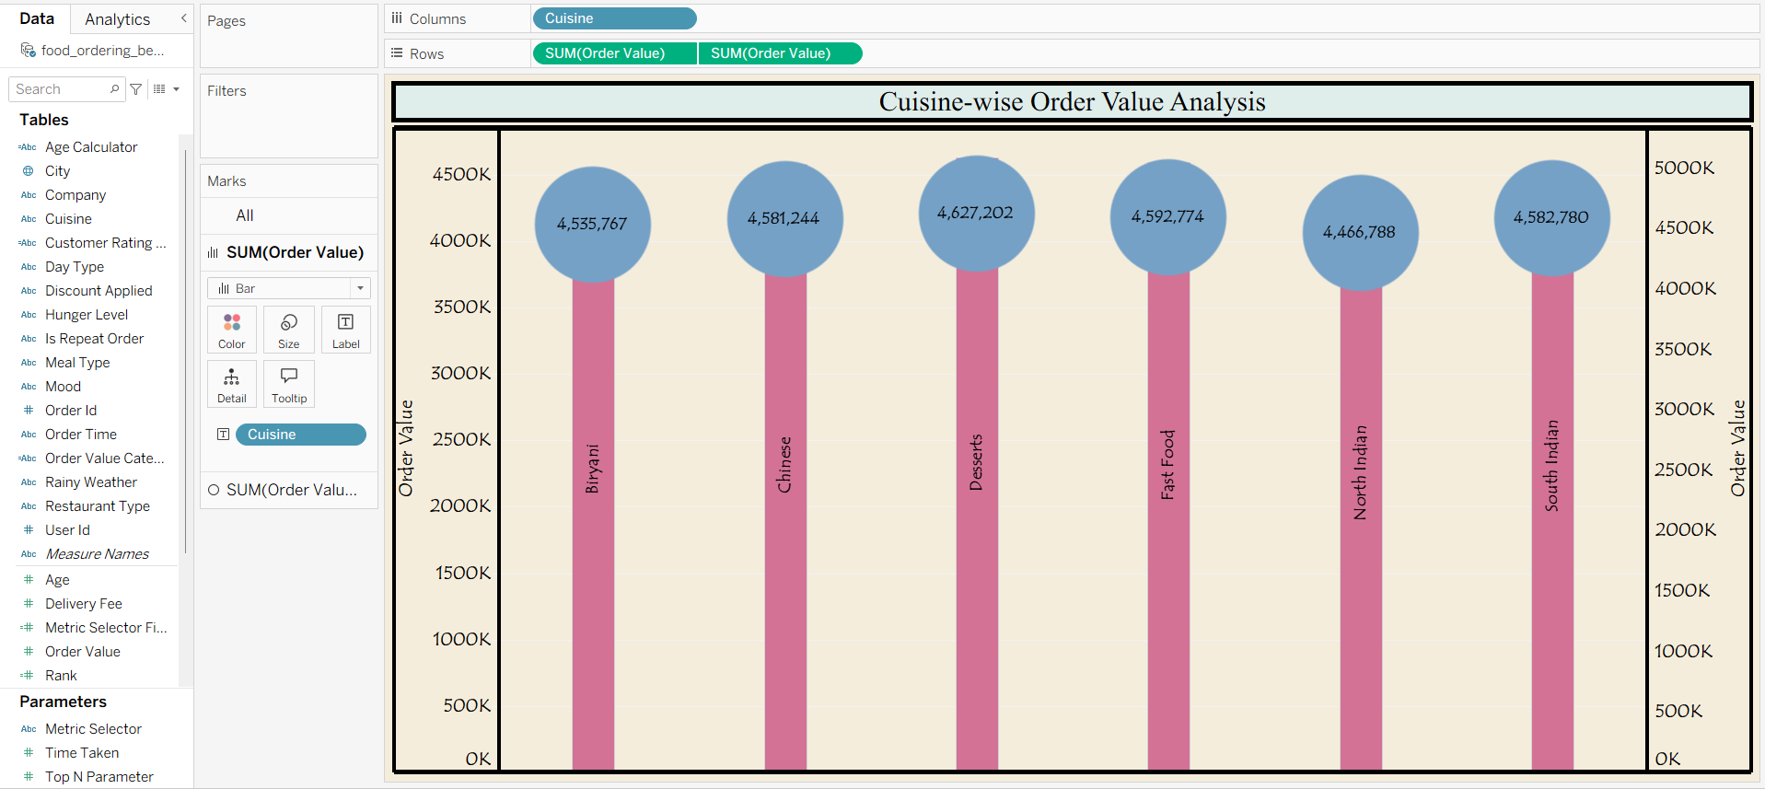
Q3. How is order value segmented across meal types and spend categories?
- Visualization: Stacked bar chart showing sum of order value by meal type, broken down by order value category (High, Low, Medium, Premium).
- Insight Provided: Spend tiers are distributed fairly evenly across all four meal types, meaning no single meal occasion (e.g., dinner) disproportionately drives premium spending. This flags an opportunity to design targeted premium offers for breakfast/snacks, which are traditionally lower-spend occasions but show similar tier distribution here.
- Screenshot of visualization:
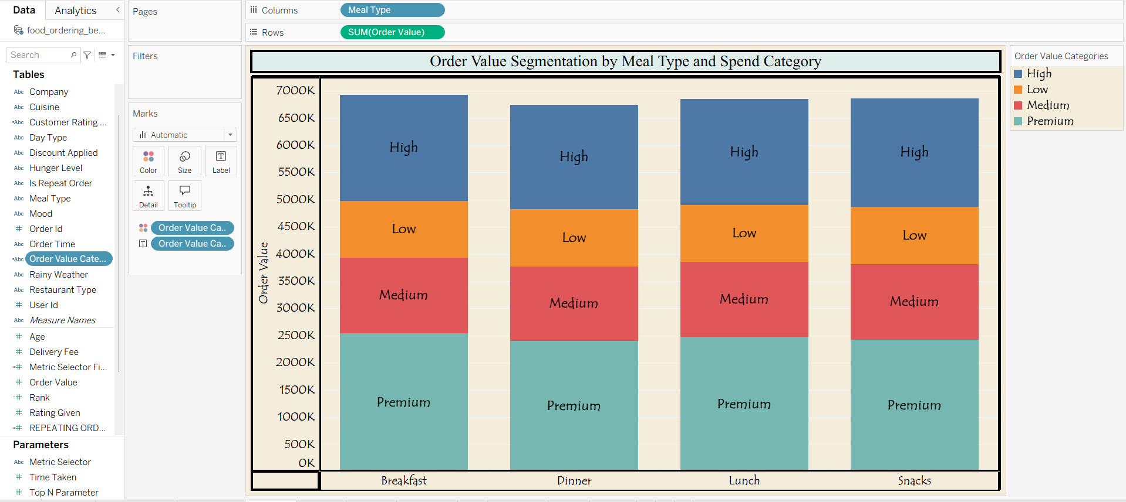

Q4. How do customer satisfaction ratings vary by cuisine and rating band?
- Visualization: Heat map (tree map style) showing average customer rating by cuisine type, colored and grouped by rating category (Excellent, Average, Good, Poor Service).
- Insight Provided: Chinese (9.448) and South Indian (9.546) cuisines show the highest satisfaction on the top-tier metric, while other metric groupings for the same cuisines range lower (as low as 2.9–3.0). This suggests satisfaction is highly dependent on which service dimension is measured (e.g., taste vs. delivery experience vs. packaging), pointing to a need for cuisine-specific quality improvements rather than a blanket strategy.
- Screenshot of visualization:
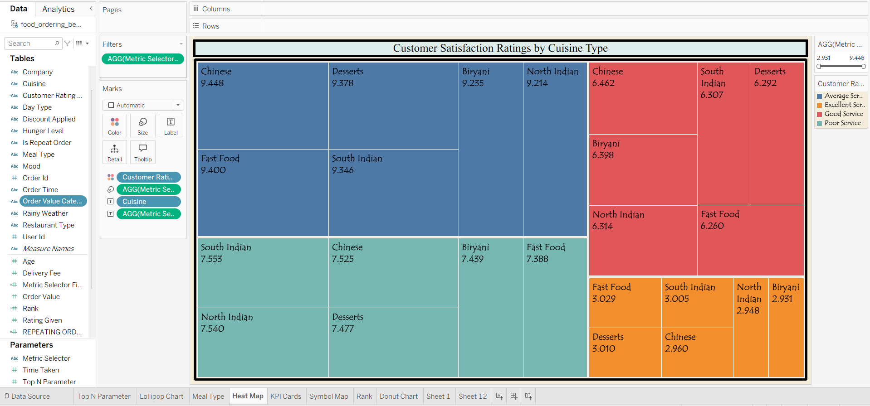

Q5. What do the key operational metrics look like at a glance?
- Visualization: KPI cards summarizing core aggregate metrics.
- Insight Provided: The dataset covers 50,000 food ordering transactions, with an average customer age of 31, an average delivery fee of ₹60, a total order value of ₹27,386,555, an average customer rating of 3, and an average order time of 7 minutes. These KPIs give a quick operational health check — the moderate average rating (3) alongside strong overall revenue suggests satisfaction has room to improve without currently limiting order volume.
- Screenshot of visualization:
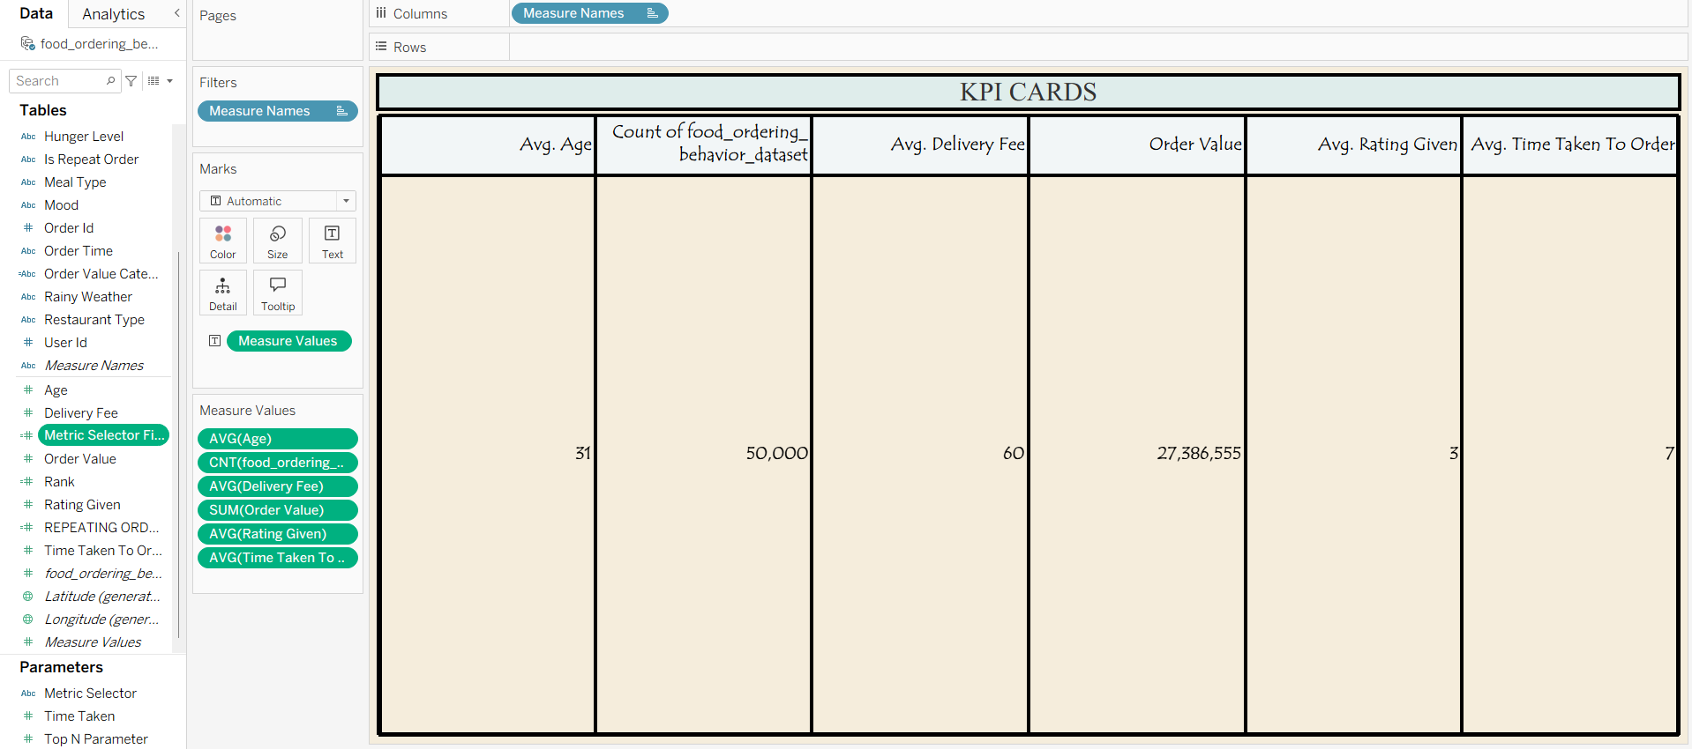
Q6. How is order value geographically distributed across cities?
- Visualization: Map (symbol map) showing sum of order value by city location.
- Insight Provided: Order value is concentrated in western and southern India — Mumbai, Pune, and Bangalore show the largest bubbles — while Chandigarh in the north shows the smallest. The geographic clustering suggests demand is stronger in metro hubs along the west/south corridor, useful for prioritizing regional delivery infrastructure and marketing spend.
- Screenshot of visualization:
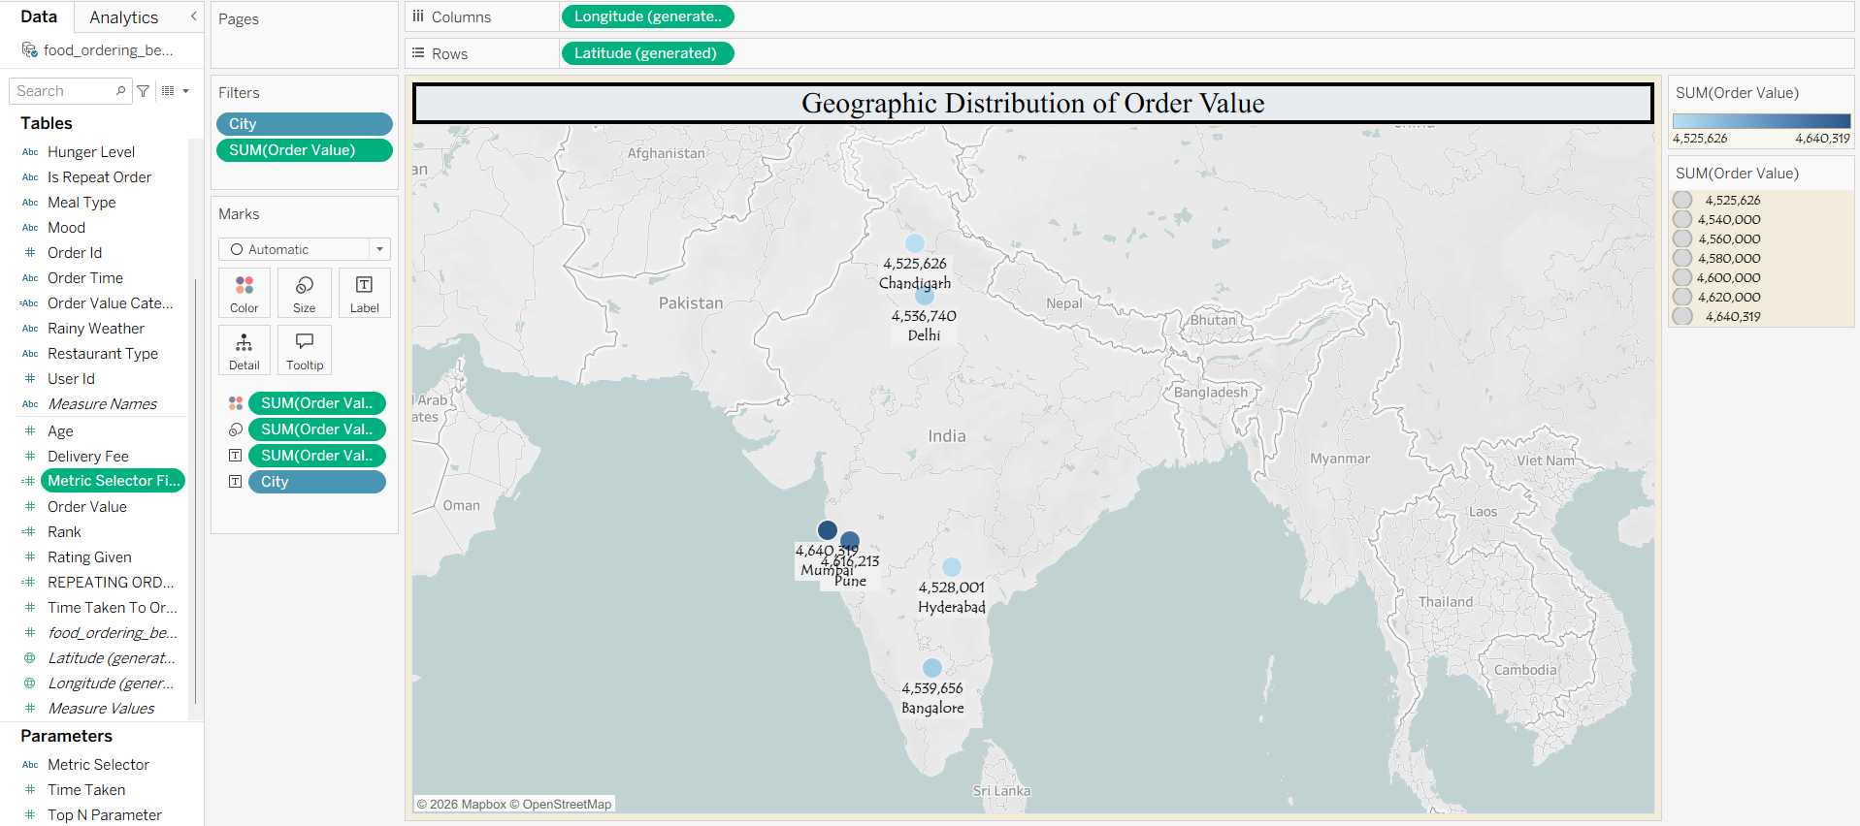

Q7. How do cities rank comparatively on total order value?
- Visualization: Ranked table showing city, rank, and total order value.
- Insight Provided: Mumbai ranks 1st (₹4,640,319) and Chandigarh ranks last at 6th (₹4,525,626). The gap between adjacent ranks is small (often under ₹15K), meaning small operational improvements — like reduced delivery time or targeted offers — could shift a city's rank position, making this table useful for setting realistic short-term city-level growth targets.
- Screenshot of visualization:
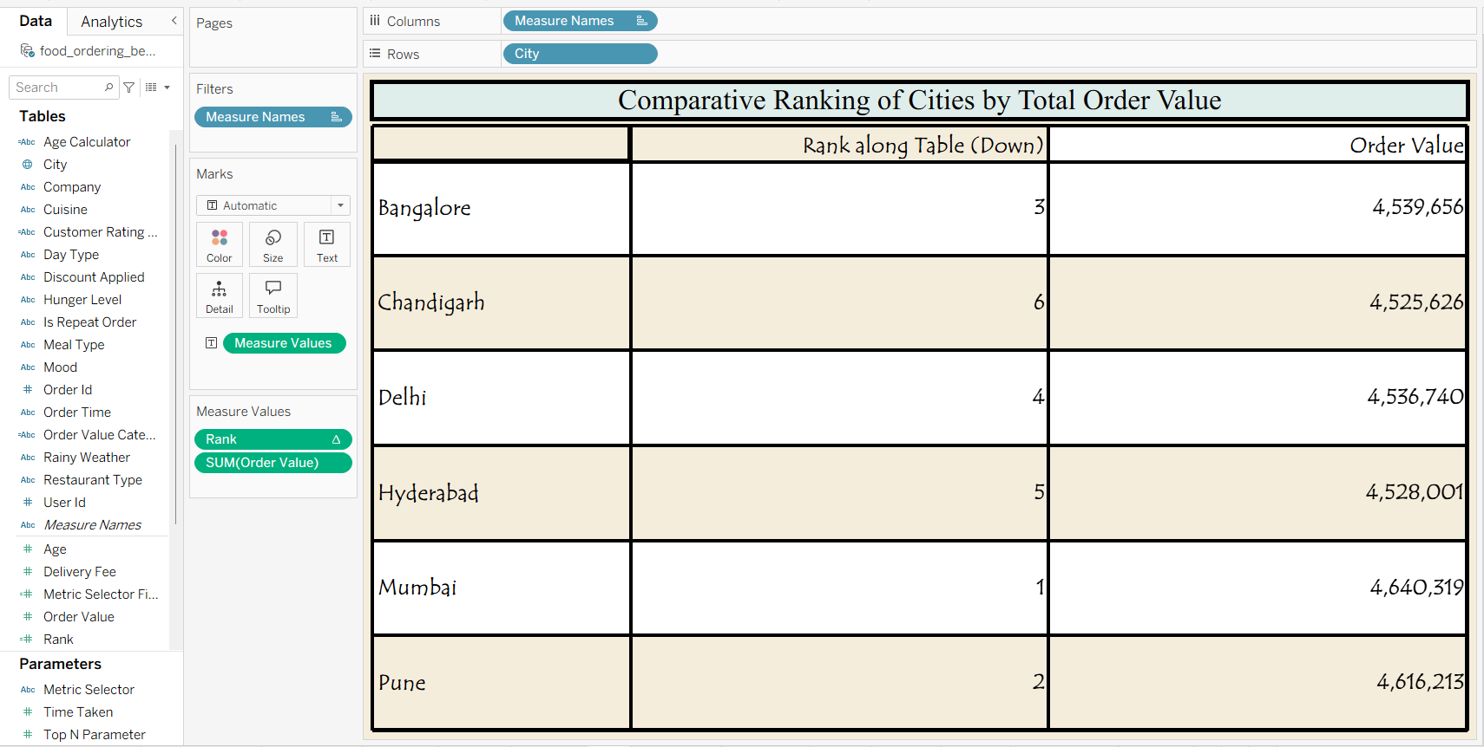

Q8. How are total orders distributed across cities?
- Visualization: Donut chart showing count of orders by city.
- Insight Provided: Order counts are nearly evenly split across all six cities, each holding roughly 16–17% share. Unlike order value, which shows more spread between top and bottom cities, order volume is uniform — implying revenue differences are driven more by order size/pricing than by how many people are ordering in each city.
- Screenshot of visualization:
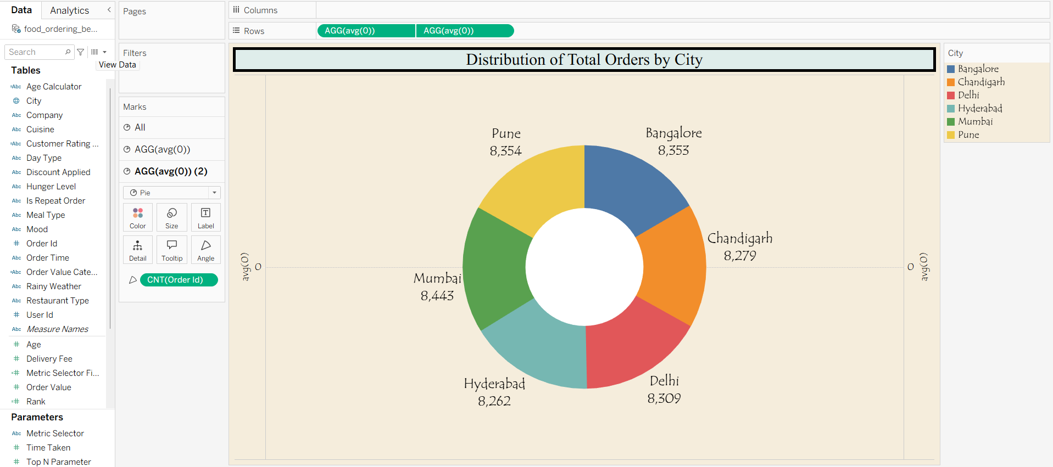
Q9. Does dining companionship type affect customer satisfaction ratings?
- Visualization: Stacked bar chart showing count of orders by company type, broken down by customer rating category.
- Insight Provided: Poor Service is the largest rating segment across all four companionship types, but the Poor-to-Excellent ratio is worst for Partner orders (5,139: 884, ~5.8:1) and best for Family orders (4,906: 922, ~5.3:1). While the difference is modest, it suggests orders placed for two people may receive slightly less careful handling than larger family orders — worth validating against delivery time or order accuracy data before drawing firm conclusions.
- Screenshot of visualization:
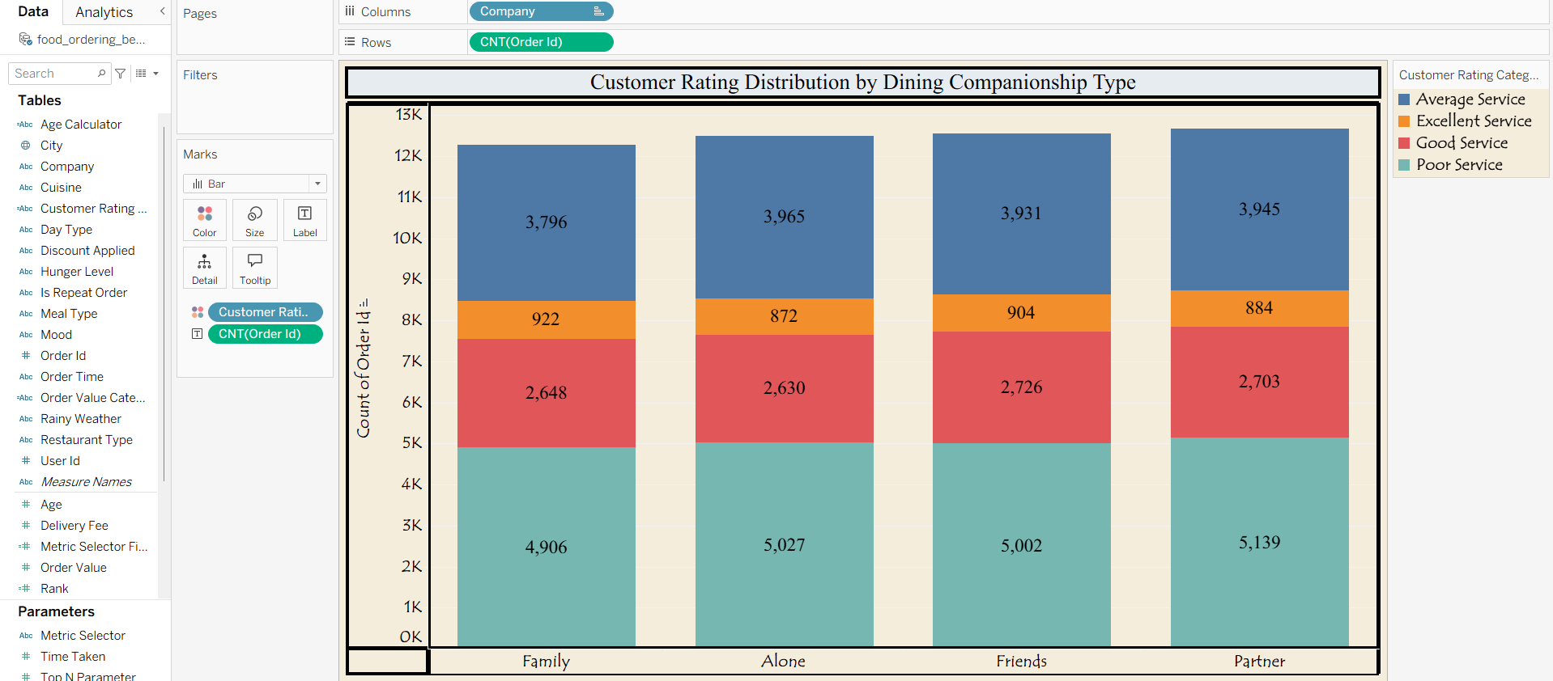

Q10. Does repeat order rate vary by generation?
- Visualization: Bar chart with reference line showing average repeating-order rate by generation (Gen Z, Young Millennials, Older Millennials).
- Insight Provided: Repeat order rate stays close to the 0.4960 average across all three generations, with no cohort significantly over- or under-performing. This indicates loyalty and retention drivers (app usability, delivery reliability, discounts) resonate similarly across age groups, so retention strategies likely don't need heavy generational segmentation.
- Screenshot of visualization:
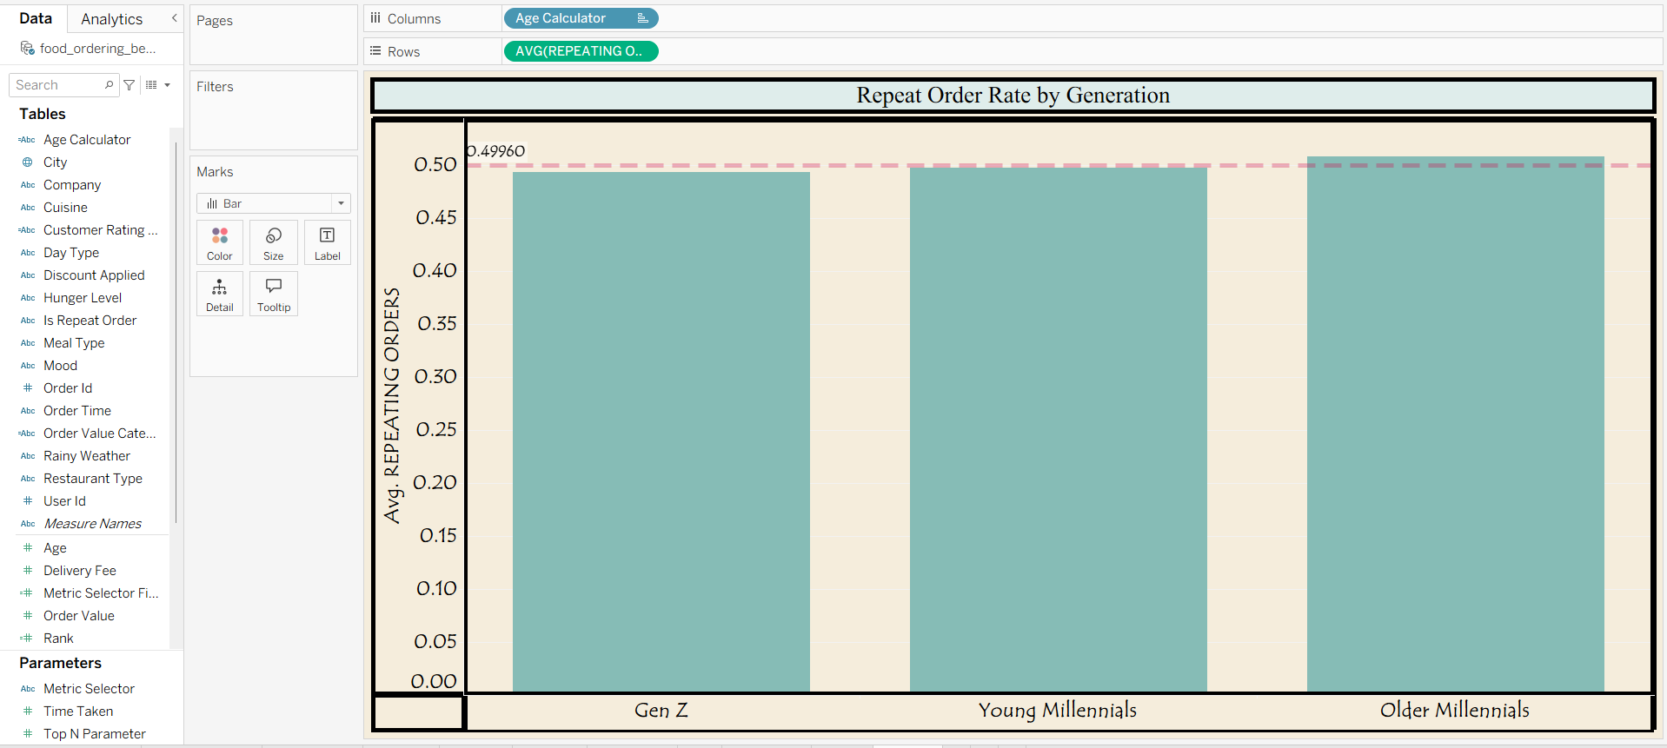

5. Dashboard
5.1. Dashboard Design
Two interactive dashboards were designed following core dashboard-design principles: a clear and intuitive layout, appropriate chart types per question, consistent colour theming, interactive filters, drill-down capability, and responsive layout.
DASHBOARD 1:
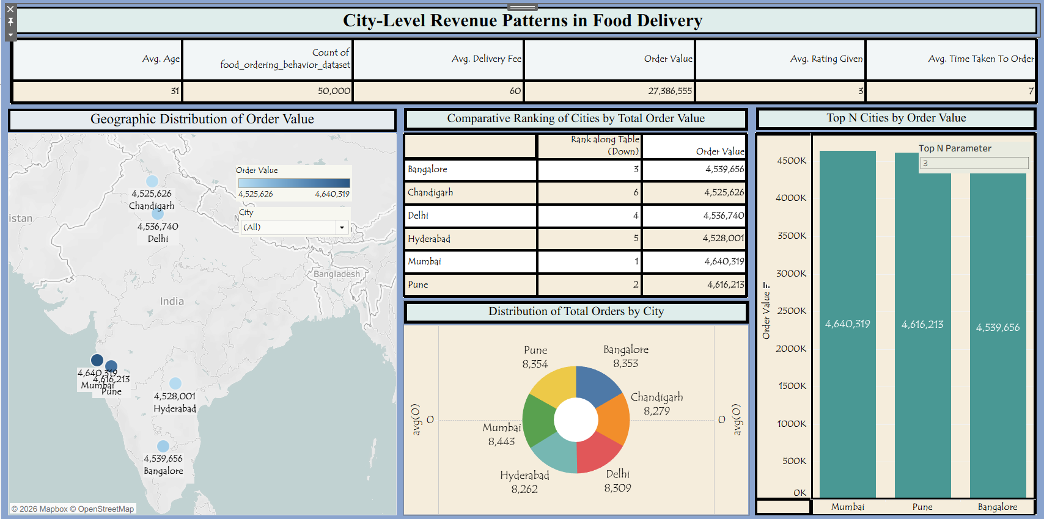

Dashboard 1: City-Level Revenue Patterns in Food Delivery
- Dataset Overview: The analysis covers 50,000 food ordering records, with an average customer age of 31, an average delivery fee of ₹60, total order value of ₹27,386,555, an average rating of 3, and an average order time of 7 minutes.
- Top Revenue City: Mumbai leads in total order value at ₹4,640,319, followed closely by Pune (₹4,616,213) and Bangalore (₹4,539,656).
- Narrow Revenue Spread: Order values across all six cities are tightly clustered between ₹4.52M–₹4.64M, indicating fairly even demand distribution rather than one dominant market.
- Order Volume Leaders: Mumbai also tops order count (8,443), while Hyderabad has the lowest volume (8,262) — though the gap across cities is minor (~180 orders).
- Bottom Performer: Chandigarh ranks last in both total order value (₹4,525,626) and is ranked 6th overall, suggesting it may need targeted promotions or delivery incentives.
Activity 2
Publish Dashboard on Tableau Public and Paste the Dashboard Public link below:
https://public.tableau.com/app/profile/manpreet.kaur7362/viz/City-LevelRevenuePatternsinFoodDelivery/Dashboard1?publish=yes

DASHBOARD 2:
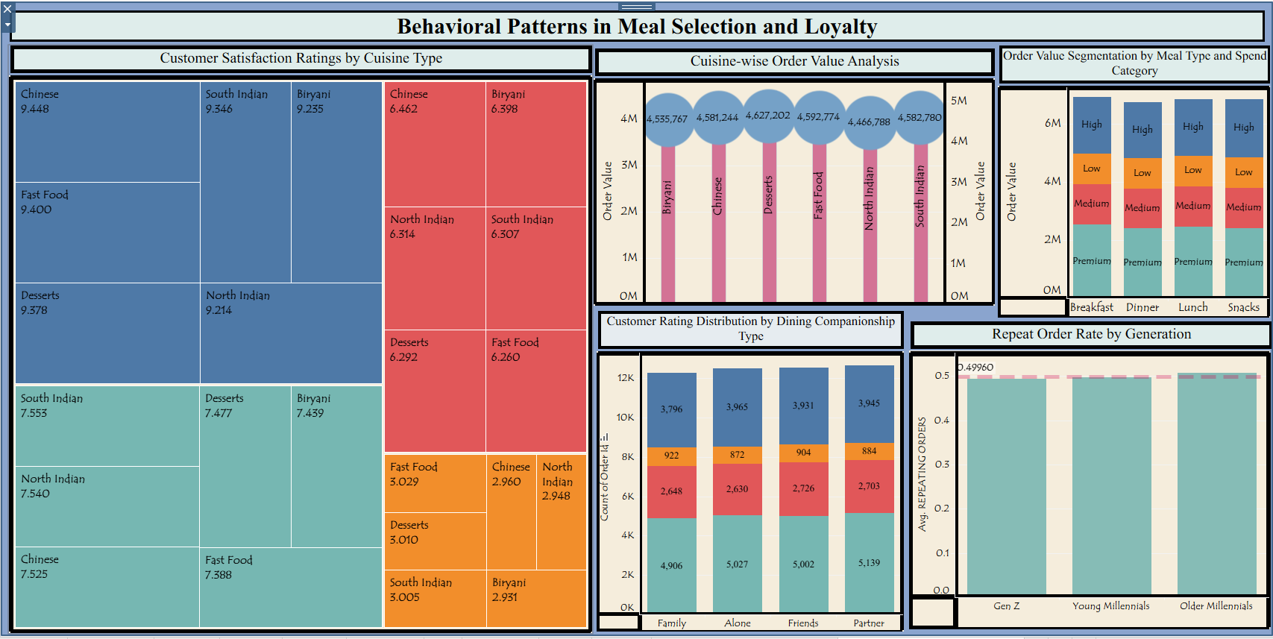
Dashboard 2: Behavioral Patterns in Meal Selection and Loyalty
- Cuisine Satisfaction: South Indian and Chinese cuisines receive the highest satisfaction scores (~9.5 range), while ratings vary more broadly across other cuisine-metric combinations (roughly 7.2–9.5), pointing to inconsistent experience quality by cuisine.
- Highest-Value Cuisine: Desserts generate the highest average order value (₹4,627,202), followed by South Indian (₹4,582,780) and Fast Food (₹4,592,774), while North Indian trails at ₹4,466,788.
- Spend Segmentation: Order value splits fairly evenly across Breakfast, Lunch, Dinner, and Snacks when broken into High/Medium/Low/Premium spend tiers — no single meal occasion dominates revenue.
- Dining Companionship Patterns: Orders placed "Alone" and with "Family" show the highest order counts (~12K each), suggesting solo and family dining are the primary consumption occasions.
- Loyalty by Generation: Repeat order rate hovers close to the 0.4960 average across Gen Z, Young Millennials, and Older Millennials — indicating loyalty behavior is fairly consistent across generational segments rather than concentrated in one group.

Activity 2
Publish Dashboard on Tableau Public and Paste the Dashboard Public link below:
https://public.tableau.com/app/profile/manpreet.kaur7362/viz/BehavioralPatternsinMealSelectionandLoyalty/BehavioralPatternsinMealSelectionandLoyalty?publish=yes

6. Report
6.1. Story Design
A Tableau Story — Analyzing Order Value and Customer Behavior Across Indian Cities — was built to guide stakeholders through a logical, sequential narrative that turns the raw transaction records into a cohesive customer-behaviour story.
ACTIVITY 1 : Story Design
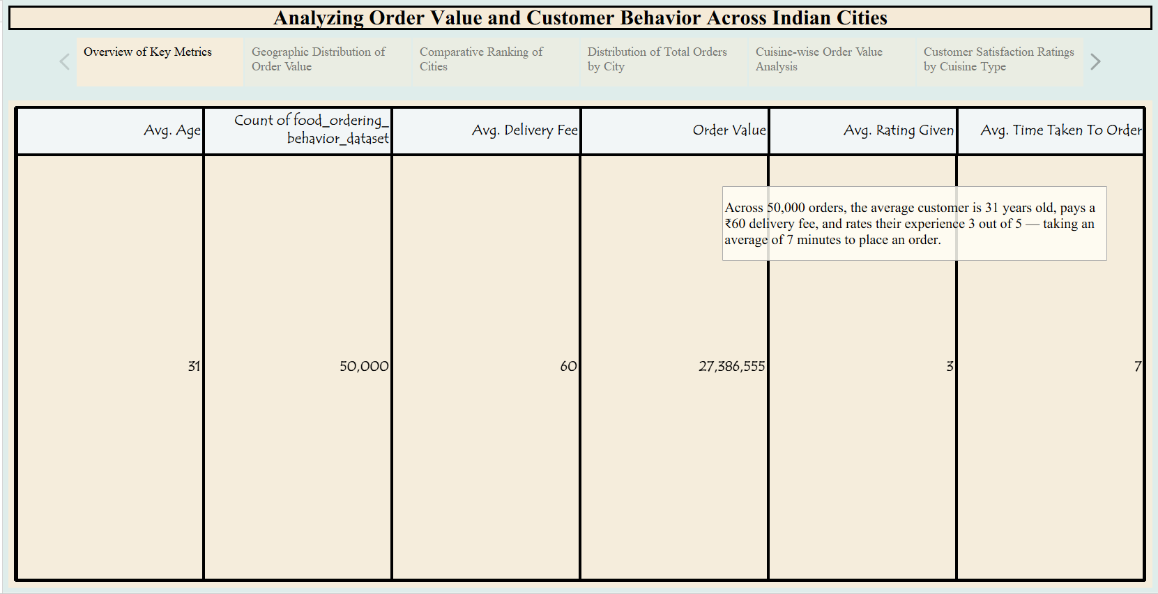

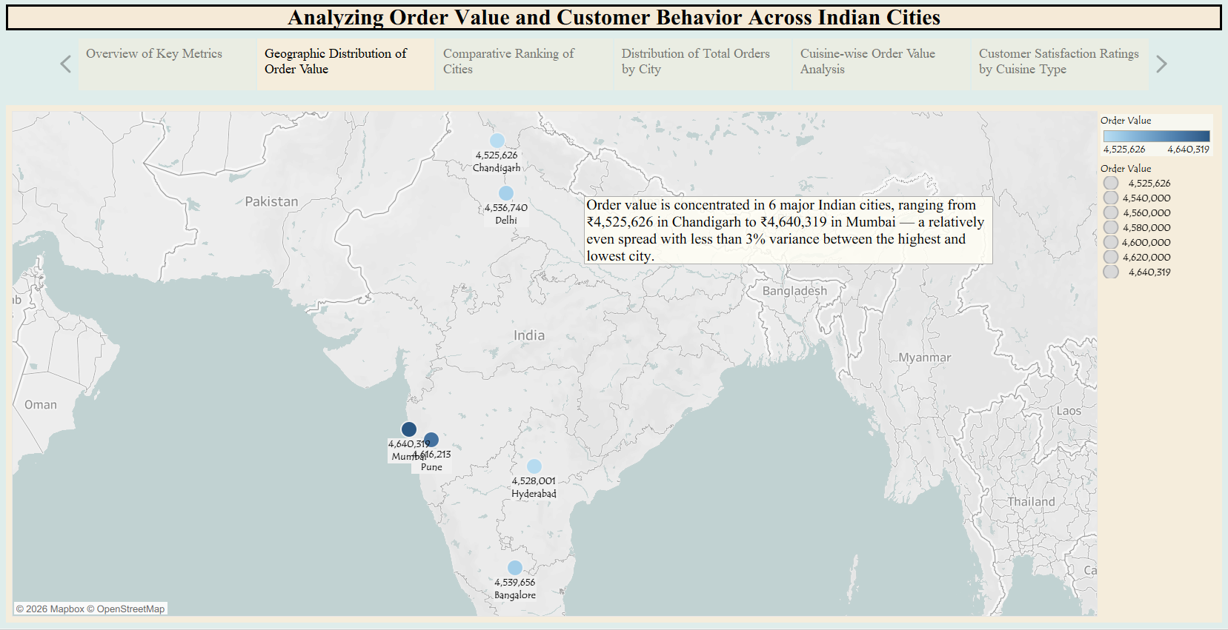
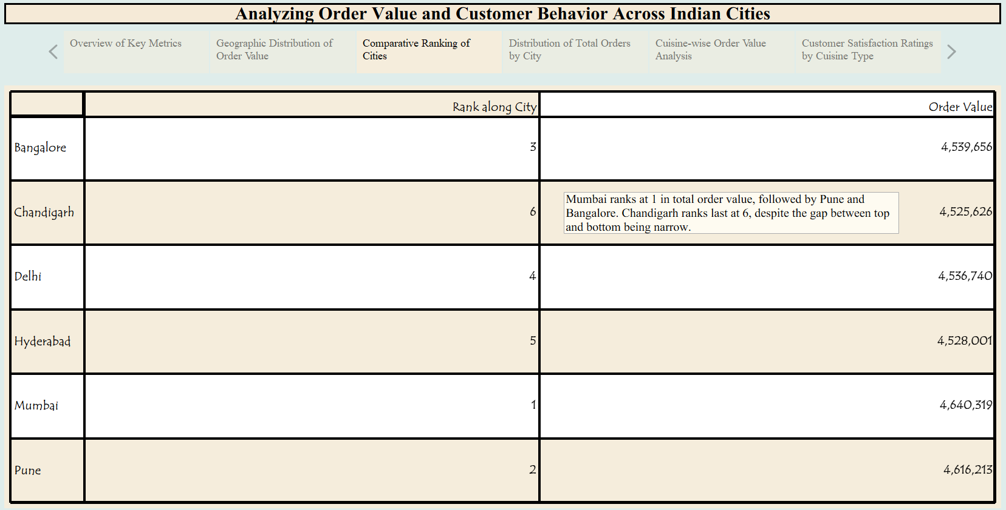

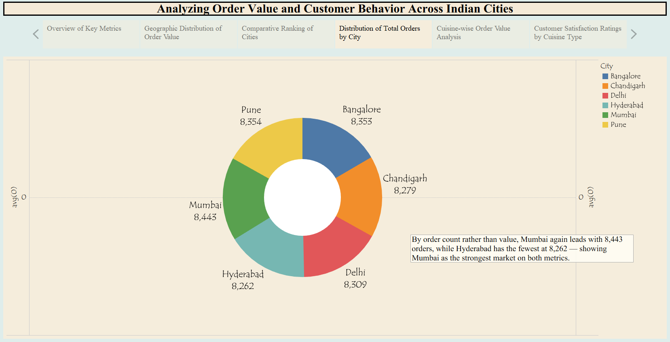

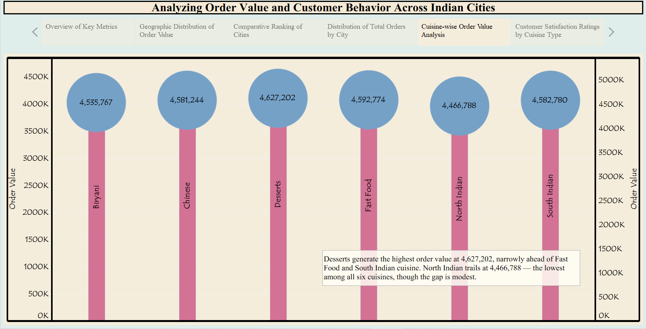

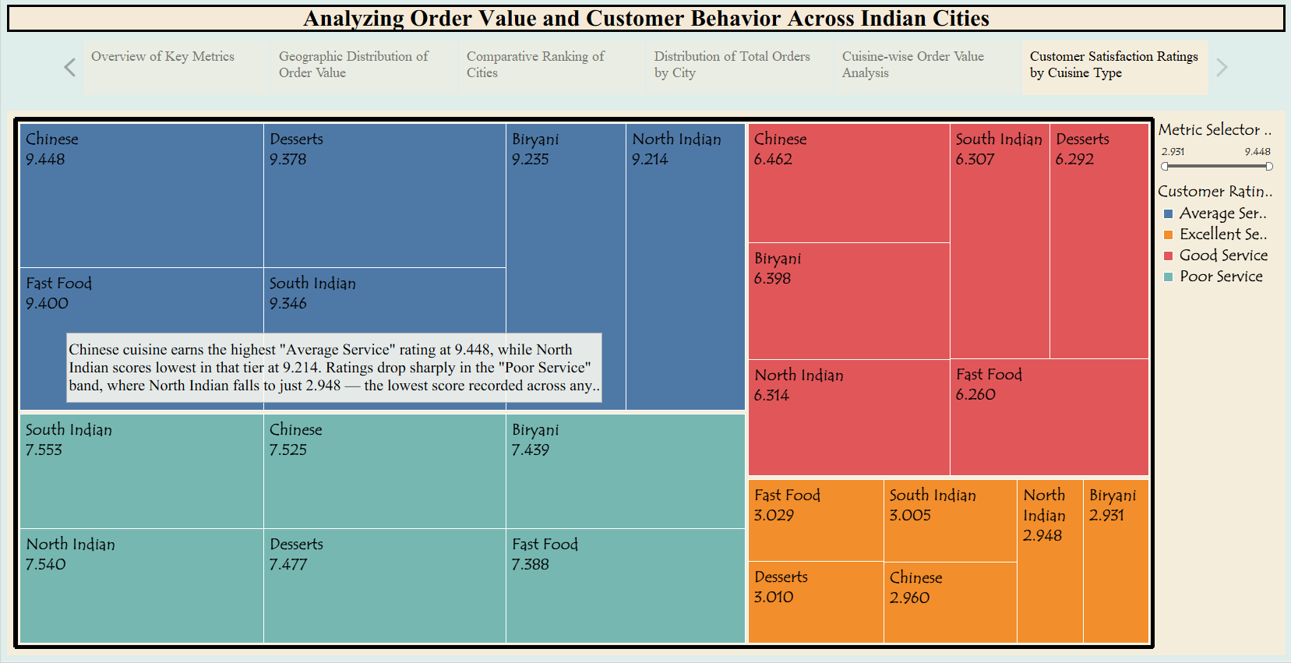

Tableau Story Narrative & Observations
By leveraging the sequential story point structure in Tableau, the Analyzing Order Value and Customer Behavior Across Indian Cities presentation guides business stakeholders through a logical progression of order metrics, turning raw transaction records into a cohesive customer-behavior narrative. Based on the interactive story points, here are the core business observations:
- Baseline Customer Profile Is Remarkably Consistent (Overview of Key Metrics, Q1): Across all 50,000 orders, the average customer is 31 years old, pays a ₹60 delivery fee, and rates their experience 3 out of 5 — taking roughly 7 minutes to place an order. This tight clustering suggests a fairly homogeneous customer base rather than distinct behavioral segments at the aggregate level.
- Geographic Spread Is Even, Not Concentrated (Geographic Distribution & Comparative Ranking, Q2–Q3): Order value is spread across 6 major Indian cities with less than 3% variance between the highest (Mumbai, ₹4,640,319) and lowest (Chandigarh, ₹4,525,626) performing markets. Mumbai leads on both order value and order count (8,443 orders), followed closely by Pune, while Chandigarh trails on both metrics — pointing to a genuinely national demand pattern rather than one dominant hub.
- Value and Volume Move Together, But Not Perfectly (Distribution of Total Orders by City, Q4): Mumbai's leadership in order count mirrors its lead in order value, reinforcing it as the strongest market on both dimensions. However, cities like Bangalore and Pune show that high order counts don't always translate to proportionally higher value, hinting at differences in average basket size across regions.
- Cuisine Preferences Show a Narrow but Meaningful Spread (Cuisine-wise Order Value Analysis, Q5): Desserts generate the highest order value at ₹4,627,202, narrowly ahead of Fast Food and South Indian cuisine. North Indian trails at ₹4,466,788 — the lowest among all six cuisines — though the modest gap suggests fairly balanced demand rather than a single runaway favorite.
- Satisfaction Ratings Diverge Sharply by Service Tier (Customer Satisfaction Ratings by Cuisine Type, Q6): Chinese cuisine earns the highest "Average Service" rating (9.448), while North Indian scores lowest in that tier (9.214). The pattern inverts in the "Poor Service" band, where North Indian falls to just 2.948 — the lowest score recorded across any cuisine-service combination — flagging North Indian as the cuisine most vulnerable to service-quality complaints despite steady order value.
Activity 2:
Publish Story on Tableau Public and Paste Public link below
https://public.tableau.com/app/profile/manpreet.kaur7362/viz/Food_Ordering010_/Story1?publish=yes
7. Performance Testing
7.1 Utilization of Data filters
To optimize dashboard performance and maintain a clean visual layout, filtering was implemented through parameters rather than traditional Quick Filters. Given the limited space available across the five dashboard views, Quick Filters were deliberately excluded to avoid visual clutter and preserve chart readability. Instead, two parameters were used to drive dynamic interactivity:
Filter/Parameter | Type | Applied On | Purpose
Top N Parameter | Integer Parameter | Ranked/aggregated views | Filters the view to display only the top N records by the selected metric, improving dashboard focus and load performance
Metric Selector | String Parameter | Customer Satisfaction Ratings by Cuisine Type (Treemap) | Toggles the displayed KPI between Avg Time Taken and Avg Order Value without needing separate sheets
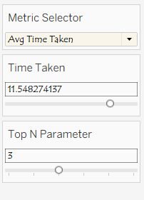

7.2 No of Calculation Field
A total of 6 calculated fields and 2 parameters were created to support segmentation, ranking, and dynamic metric selection across the dashboards.
No. | Field Name | Logic Type | Purpose
1 | Order Value Categories | IF/ELSEIF | Segments orders into Premium/High/Medium/Low tiers
2 | Customer Rating Category | Nested IF/AND | Classifies service as Excellent/Good/Average/Poor Service
3 | Metric Selector Field | CASE + Parameter | Dynamically switches the displayed KPI
4 | Rank | Table Calculation | Ranks cities by total order value
5 | Age Calculator | IF/ELSEIF | Segments customers into Gen Z/Young Millennials/Older Millennials
6 | Repeating Orders | IF/ELSE | Converts Yes/No repeat-order flag into binary 1/0

- Order Value Categories
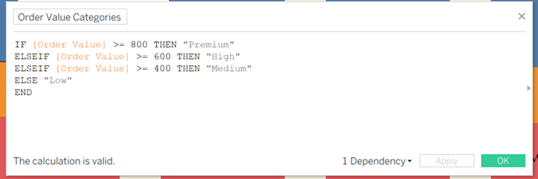

- Customer Rating Category
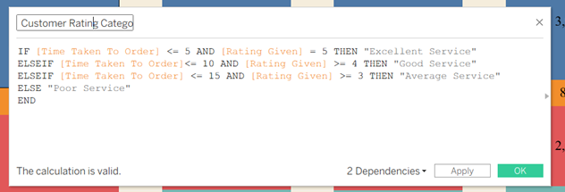

- Metric Selector Field
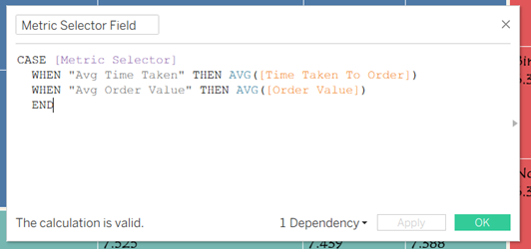

- Rank
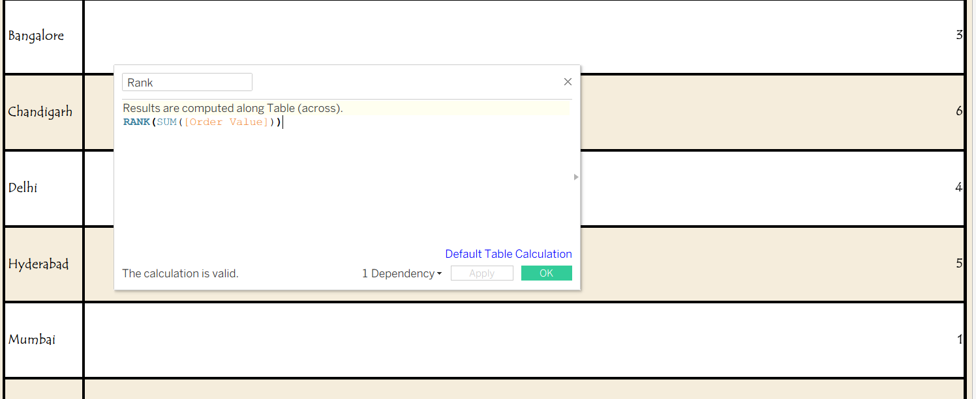

- Age Calculator
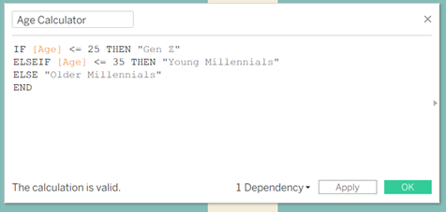

- Repeating Orders
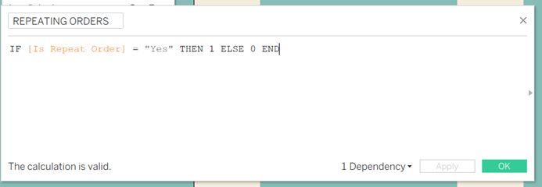

7.3 Number of Visualizations
Component | Count
Chart visualizations (Q1–Q10) | 10
Dashboards | 2
Story points | 6
Total visual assets | 18

10 charts answer the individual business questions. These charts are combined into 2 dashboards, and 6 of them are arranged into a Tableau Story for presentation.

8. Conclusion/Observation
Based on the analysis of order value, ratings, and customer behavior across the dataset, a few clear patterns emerged:
- Average order value is ₹547.73 (range ₹100–₹999), and "High" value orders dominate across all four meal types (Breakfast, Lunch, Snacks, Dinner), while Premium and Medium orders are rare.
- Order value is fairly similar across cities — Chandigarh and Delhi are almost tied at around ₹45 lakh each. By rank, Bangalore comes 3rd, Delhi 4th, Hyderabad 5th, and Chandigarh 6th.
- Average rating given by customers is 3 out of 5.
- Cuisine type affects ratings — Chinese, Desserts, Fast Food, and South Indian score higher (9.2–9.4), while Biryani and North Indian score lower (6.2–6.5).
- Who the customer ordered with (alone, partner, family, friends) doesn't affect the rating much — all four groups score close to each other, suggesting cuisine has more impact on satisfaction than company does.
- Average time taken per order is 7 minutes, which falls under "Good Service" in the rating logic.
- Customer age ranges from 18 to 44, covering Gen Z through older millennials.

9. Future Scope
While the current analysis covers order value, ratings, and customer behavior, there's room to take this further:
- Add real order timestamps instead of just time-of-day buckets — right now the data only shows morning/afternoon/evening/night, so we can't tell if orders are increasing over weeks or months. Actual dates would let us track real trends over time, not just time-of-day patterns.
- Build a simple model to predict which customers are likely to reorder or stop ordering — using signals like mood, hunger level, and weather that are already in the data. This would help identify at-risk customers before they stop ordering, instead of just noticing after the fact.
- Expand location data beyond city level to specific zones or areas — this would make the geographic analysis more precise, showing exactly which neighborhoods or areas within a city drive the most orders, instead of just city-wide totals.
- Move from a static CSV file to a live-connected data source — so the dashboard updates automatically as new orders come in, instead of needing a manual refresh every time.
- Look at repeat order behavior more closely — for example, checking whether certain cuisines or cities have noticeably higher repeat rates than others, which could point to what's actually keeping customers coming back.

10. Appendix
10.1. Source Code (if any)
Not applicable. This project was developed using Tableau's visual interface; no traditional source code was written.

10.2. GitHub & Project Demo Link
Project Demo Video: https://drive.google.com/file/d/18FKS7KS4wBhQdbvNgHOYciyYo6GeyvjI/view?usp=drive_link

GitHub Repository: https://github.com/manpreetkaurmi7892-dot/Consumer-Food-Buying-Behaviour

THANK YOU

